Anchor Point Risk

SPECIALIST RATING SERVICES
Which tail should the challenger carry?
What the exponential, power-law and client-shape scenarios do in the LGD Tail Extension app | 3 October 2026
A debug zip from the risk suite carries a run-off triangle that stops where the data stops. For the cohort 44 file generated on 2 October 2026 the last observed bucket is 96, so an account valued 60 months after default sees only 37 buckets of recoveries and its LGD is overstated by truncation alone. The LGD Tail Extension app repairs that by continuing each row beyond its last credible bucket, and a scenario chooses how.
Three tail shapes are available. All three are always computed for every zip; the scenario's Method decides which one is reported as the selected LGD. This note explains what is shared between them, what each shape assumes, what it did to the seven cohorts delivered on 2 October 2026, and which to use when.

What every scenario shares
A scenario is a named set of parameters applied to every zip in a project, with any zip free to override a parameter for itself. Whichever shape is chosen, the same five steps run first.
- Observed recoveries are kept as delivered up to the last credible bucket: the last bucket whose opening exposure is at least MinExposure, R100 million by default. Thinner buckets are treated as unobserved and replaced by the fitted tail.
- The level of the tail is set per TermStep row: a scale makes the shape pass, on average, through the last W credible buckets (W = 12 by default). Rows differ a lot in level, so the level is fitted row by row and only the shape is shared.
- Each row is extended to MaxBucket (480 in the current scenarios) as observed values, then scale × shape, never below the hazard floor (0 by default).
- Recoveries are discounted at the rate implied by each file, for example 17.71% a year for cohort 44 and 21.75% a year for ALL, and LGD = 1 − the discounted sum.
- For TermSteps beyond LastTS the base row's extended cash curve is rolled forward, so the LGD table reaches the Target TermStep (360 in the current scenarios) even where no row was observed.
The only thing that changes between the three methods is the curve used for the shape. Figure 1 shows the three tails fitted to the first row of cohort 44, on a log scale so the rate of decay is visible as the slope.
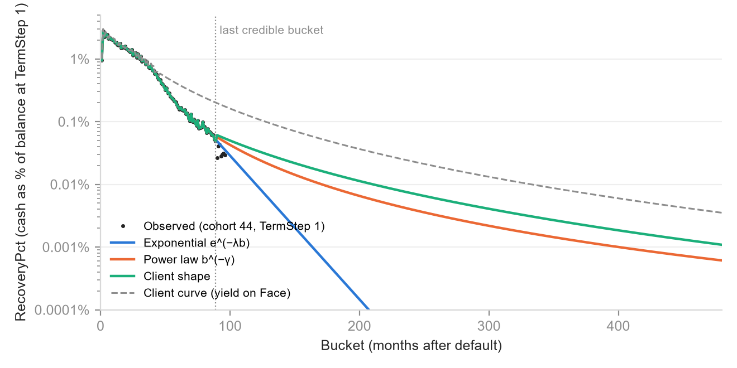
Figure 1. Cohort 44, TermStep 1, debug file of 2 October 2026. Observed RecoveryPct to the last credible bucket (89), then each shape's continuation to bucket 480. The dashed line is the client's own yield curve for cohort 44, to which the client shape is proportional.

Method 1: exponential decay
The shape is e^(−λb), where b is the bucket number. Each month the recovery rate falls by the same proportion, so the tail has a constant half-life of ln 2 ÷ λ months.
λ is not chosen; it is fitted by a log-linear regression of ln RecoveryPct on bucket number along the reference row (TermStep 1 by default) between FitStart (bucket 24, past the early hump) and that row's last credible bucket. For cohort 44 the fit gives λ = 0.0528, a half-life of 13.1 months. For cohort 22 it gives λ = 0.0233 and a half-life of 29.8 months: a much flatter tail, because that book keeps collecting for longer.
This is the challenger's own view of itself. It extends the steep decay seen in the observed data and adds the least recovery of the three. It is the independent, conservative scenario.
Exponential can raise a mid-book LGD
Because the fitted tail also replaces the thin observed buckets beyond the credibility cut, a row whose late observed buckets were noisy but generous can end up with a lower recovery than the file gave it. In the hand-built VB44 workbook of 2 October 2026 this showed at TermStep 48, where LGD moved from 0.848 to 0.853. It is not an error; it is the credibility cut doing its job.

Method 2: power law
The shape is b^(−γ). The recovery rate still falls every month, but by a shrinking proportion, so the tail is heavier than the exponential and never reaches a fixed half-life. γ is fitted the same way as λ, by regressing ln RecoveryPct on ln b over the same window.
For cohort 44 the fit gives γ = 2.71; for cohort 22, γ = 1.70. A heavier tail means more recoveries counted, so on every cohort with a client curve the power law sits between the exponential and the client shape, or level with both where the tail adds nothing.
This is the second independent view: it uses only the challenger's own data, but it assumes that late collections persist the way long-run recovery books tend to. Use it as the middle estimate when the exponential looks too harsh and the client curve is not accepted.

Method 3: client-curve shape
The shape is the client's own log-normal recovery curve for the cohort, taken from the prototype Curves sheet of the July 2026 valuation (monthly yield on Face by month on book, t = 1 to 553). The app ships the six prototype curves (cohorts 11, 15, 22, 23, 25 and 44) and matches each zip to the curve with the same label. A project can upload replacement curves.
Nothing about the level is borrowed: the scale is still fitted to the challenger's own last credible buckets. What is borrowed is the rate of decay beyond them. The challenger's tail is therefore aligned to the client's by construction, which makes this the answer to a specific question: what would the challenger show if we accepted the client's tail? It adds the most recovery of the three.
The ALL zip has no client curve
ALL combines every cohort, and the client has no curve for it. A scenario on Method 3 fails for ALL until an override names a cohort curve for it, a curve labelled ALL is uploaded, or the override switches that zip to Method 1 or 2. The app reports the failure against that zip only; the other zips still run.
Reading the gap between the shapes
The spread between Method 1 and Method 3 is the alignment question itself, expressed in LGD points. For cohort 44 it is 0.0132 on the exposure-weighted LGD (0.6112 against 0.5980). The challenger's observed tail decays with λ ≈ 0.053, while the client's log-normal tail from month 96 to 300 decays with an effective λ ≈ 0.013, so the two cannot both be right beyond the data. The scenario makes that choice explicit instead of burying it in a truncated triangle.

What the three shapes did to the seven cohorts
Table 1 shows the exposure-weighted LGD across all TermSteps for each debug zip generated on 2 October 2026, under one scenario: Target TermStep 360, MaxBucket 480, MinExposure R100 million, W = 12, FitStart 24, no overrides except Method 1 for ALL. Weights are the opening exposure at each TermStep, in Rand.

Cohort | Observed TermSteps | Rate in file | Original LGD | Exponential | Power law | Client shape | λ fitted | Half-life (months)
11 | 302 | 21.28% | 0.9799 | 0.9799 | 0.9799 | 0.9799 | 0.0173 | 40.0
15 | 329 | 28.98% | 0.9549 | 0.9548 | 0.9548 | 0.9548 | 0.0155 | 44.8
22 | 152 | 17.64% | 0.8661 | 0.8653 | 0.8630 | 0.8612 | 0.0233 | 29.8
23 | 268 | 11.45% | 0.8983 | 0.8979 | 0.8967 | 0.8960 | 0.0145 | 47.7
25 | 289 | 24.80% | 0.9124 | 0.9123 | 0.9123 | 0.9123 | 0.0239 | 29.0
44 | 97 | 17.71% | 0.6120 | 0.6112 | 0.6034 | 0.5980 | 0.0528 | 13.1
ALL | 329 | 21.75% | 0.9485 | 0.9485 | 0.9485 | no curve | 0.0157 | 44.1
Table 1. Exposure-weighted LGD by tail shape, LGD Tail Extension app, debug zips of 2 October 2026. Original LGD is the file's own figure, which the risk suite floors at the previous TermStep's LGD; the app reports that floor separately.
Two things stand out. The long books (cohorts 11, 15 and 25, with 289 to 329 observed TermSteps) barely move: their triangles already run long enough that the tail adds almost nothing, whichever shape is used. Cohort 44, with 97 observed TermSteps and a last credible bucket of 89, moves most, from 0.6120 in the file to 0.5980 under the client shape. Truncation is a problem of young books.
Figure 2 shows where the movement sits within cohort 44: the gap between the file and the three shapes widens with TermStep, because the later a row starts the fewer observed buckets it has left and the more of its recovery the tail must carry.
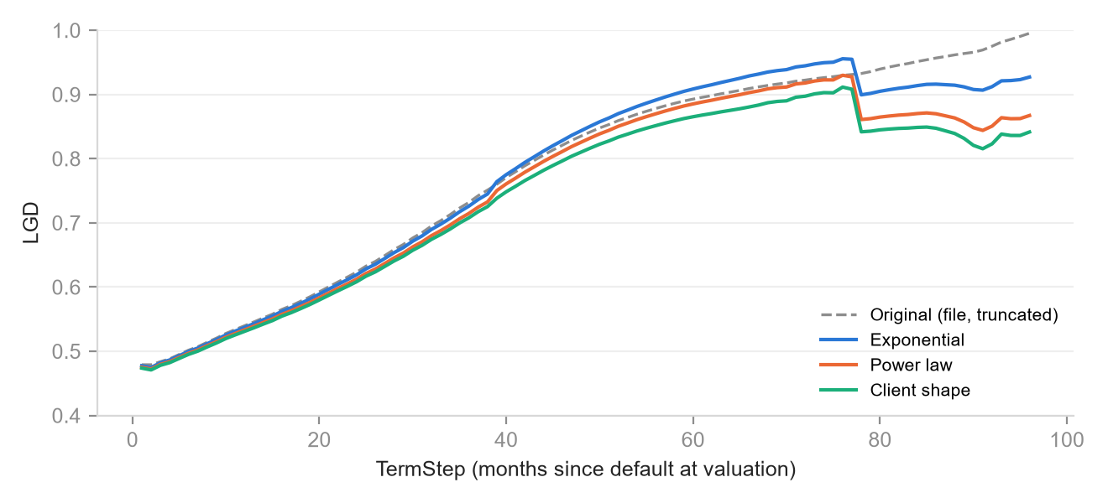
Figure 2. Cohort 44, LGD by TermStep, debug file of 2 October 2026. Original (file) against the three extended shapes.
The step down after TermStep 77 in Figure 2 marks the rows whose opening exposure falls below the R100 million cut (R61 million at TermStep 78). With no credible bucket, the fallback keeps every observed bucket, and the noisy late data lift the extension. Lowering LastTS to 77 in the scenario hands those rows to the rolled-forward base row instead.

The other levers in a scenario
The method is the headline choice, but a scenario carries fourteen other parameters. The ones that change results materially are listed here; the rest keep the workbook defaults.

Parameter | Default | What it does
MinExposure | R100m, or % of opening | Credibility cut. Lower it to keep more of the thin observed tail; raise it to lean on the fitted shape sooner.
Window W | 12 buckets | How many credible buckets set the tail's level. Wider is steadier; narrower follows the last observations.
FitStart | 24 | First bucket in the λ / γ regression. Skips the early hump of fresh collections.
λ or γ override | empty | Replace the fitted decay with a given value, for example to test the client's λ ≈ 0.013 on the challenger's own level.
LastTS | last observed | Rows beyond it come from the rolled-forward base row. Lower it (about 80 for cohort 44) when late rows rest on too little exposure.
Target, MaxBucket | 300, 420 | How far the LGD table and the buckets reach. Keep MaxBucket at Target plus the 120-month valuation horizon.
Client curve | the zip's category | Which curve Method 3 uses. Needed for ALL.

Which scenario to use
Run all three and keep all three on the page. The exponential is the independent floor on recoveries, the power law the independent middle, and the client shape the alignment case. The selected method for the ECL number is then a policy decision, taken knowing the size of the gap rather than discovering it in audit.
The extension is an assumption, not data
Beyond the last credible bucket nothing is observed. The app shows the tie-out of its replica to the file (zero to 1e-9 on every zip of 2 October 2026) so the observed part can be trusted, and labels every derived TermStep as derived. Treat the tail as a modelling choice to be disclosed, with the shape, λ or γ, and the credibility cut stated alongside the LGD.

Henry Edwards
Director, Head of Credit
Anchor Point Risk

